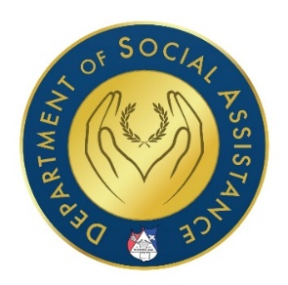

The Apostolic Assembly of the Faith in Christ Jesus

General Assistance Application

All information in this form is protected by the Law of God and the civil authority granted to us. All information is kept confidential.

The Apostolic Assembly of the Faith in Christ Jesus has established the Department of Social Assistance, with a mission to fulfill a Biblical duty as written in Isaiah 1:17 and James 1:27.

Our mission is to:
- Relieve oppression
- Defend the fatherless
- Plead for the widows
- Supplement ministers that reach retirement age without economic resources

- Please complete this application to the best of your ability. Once complete, please submit it in to your Pastor. Your Pastor will review your application and forward it to the district supervising Bishop.
- Include any supporting documentation that may assist us in considering your approval.
- If you need help completing this application, please call (909) 987-3013 during business hours, which are Monday through Friday 8am to 5pm and ask to be directed to Department of Social Assistance.

agreement
- Supporting documentation must be included with application.
- All signatures must be present in order to process application.
- By submitting this application, you authorize The Department of Social Assistance to make inquiries into the need that you are applying for.
- The Department of Social Assistance will contact you by writing or phone of the decision reached within a reasonable time.
- Application is subject to approval based on availability of funds.

This is an official application for General Assistance from the Department of Social Assistance of the Apostolic Assembly of the Faith in Christ Jesus.

